LGB with TF-IDF features (max_features=20000, ngram_range=(1,2) for word, ngram_range=(2,6) for char)

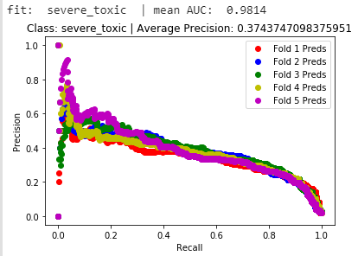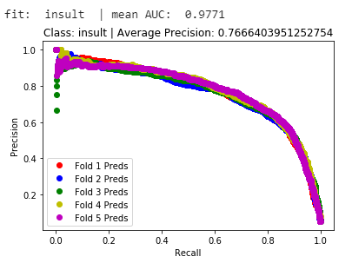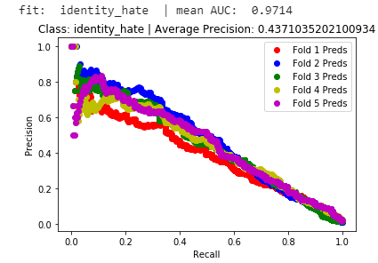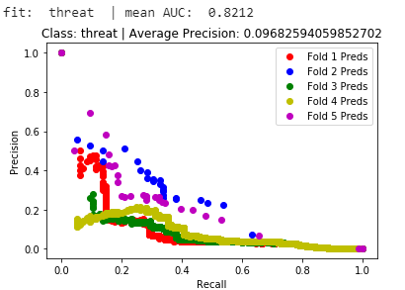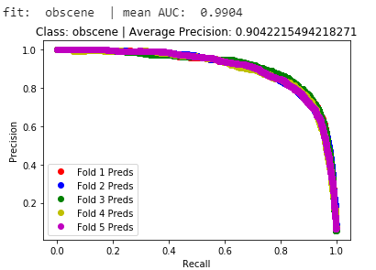 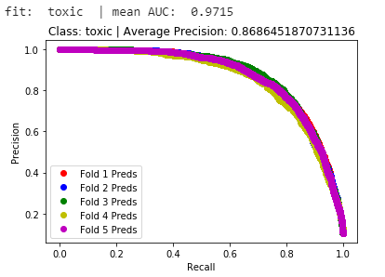

NB-SVM with only word TF-IDF features (ngram_range=(1,2), max_features=20000) & Hyperopt

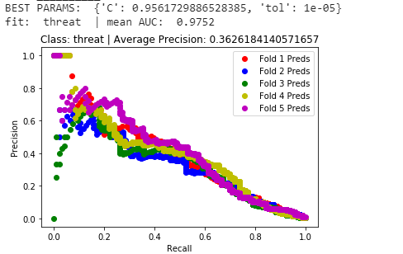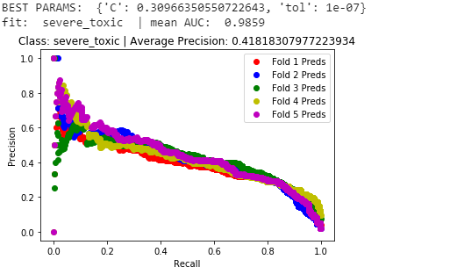

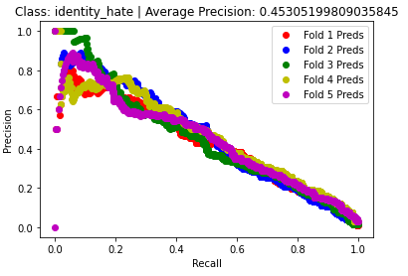

**Bi-directional LSTM**

[Tokenizer (20000) -> Embedding (100) -> Bi-directional LSTM (100) -> Dropout (0.2) -> Dense (Sigmoid)

Epochs = 10, batch_size = 64, validation_split = 0.2]

lstm_units = 50

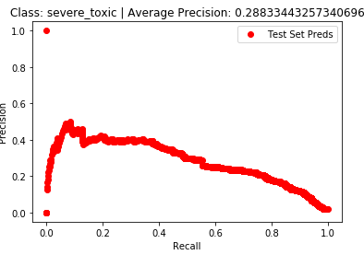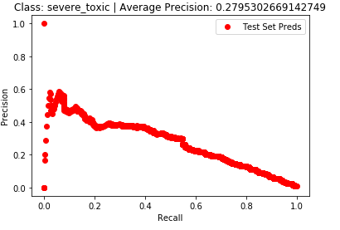

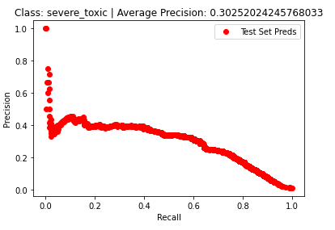

LightGBM With TFIDF Features and SVMSMote and TomekLinks (Severe_Threat)

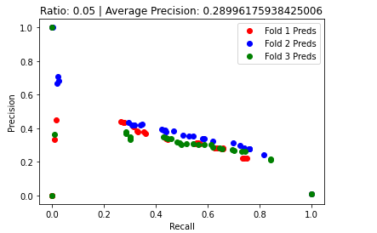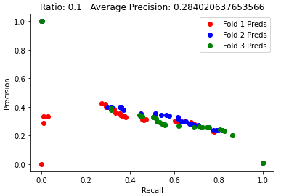

XGB w/ TFIDF + bagging/feature fraction = 0.8

and scale_pos_weight

LGB w/ TFIDF + bagging/feature fraction = 0.8

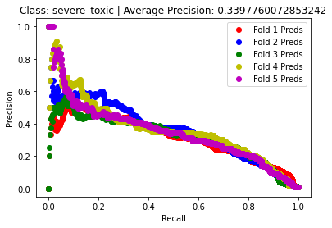

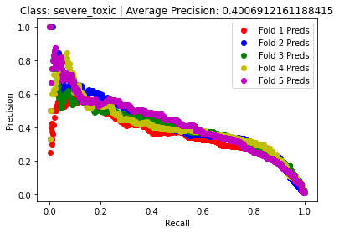

XGB w/ TFIDF + bagging/feature fraction = 0.8

and NO scale_pos_weight,xgb_rounds=500

XGB w/ TFIDF + bagging/feature fraction = 0.7

and metadata features (pos + spam)

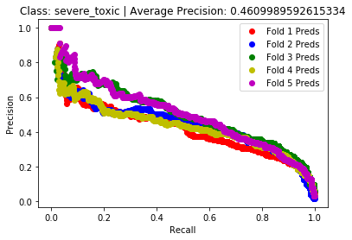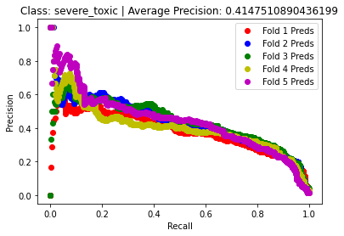

XGB w/ TFIDF + bagging/feature fraction = 0.7

and metadata features (pos + spam) + SMOTE(0.05,kn=5)

XGB w/ TFIDF + bagging/feature fraction = 0.7

and metadata features (pos + spam) + SMOTE(0.1,kn=5)

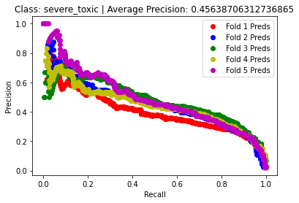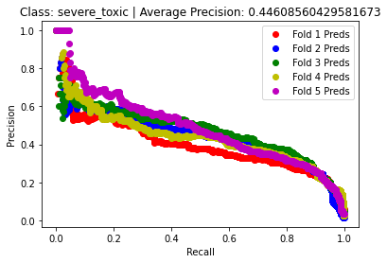

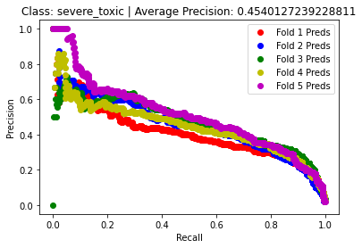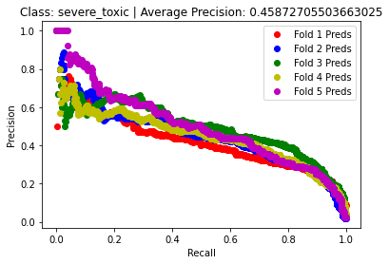

XGB w/ TFIDF + bagging/feature fraction = 0.7

and metadata features (pos + spam) + SMOTE(0.025,kn=10)

XGB w/ TFIDF + bagging/feature fraction = 0.7

and metadata features (pos + spam) + SMOTE(0.05,kn=10)

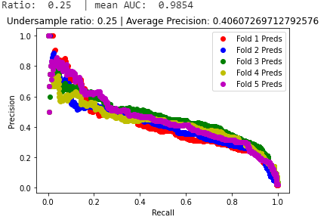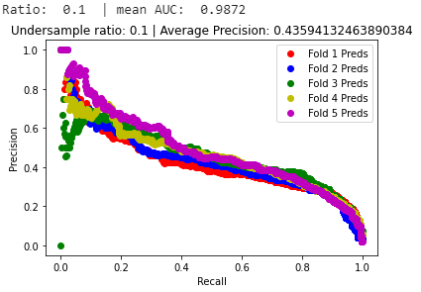

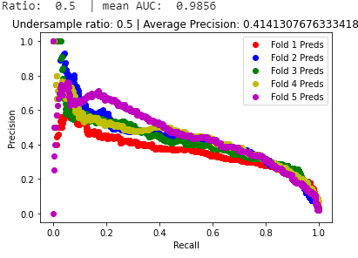

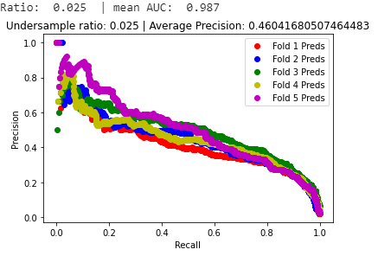

XGB w/ TFIDF + bagging/feature fraction = 0.7

and metadata features (pos + spam + added swearwords)

XGB w/ TFIDF + bagging/feature fraction = 0.7

and metadata features (pos + spam + added swearwords – NO LEMMATIZATION)

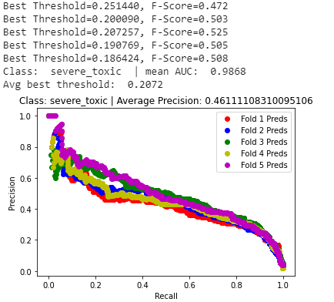

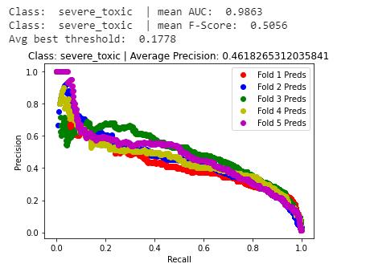

RandomForest w/ TFIDF + num_estimators=200 + NO SMOTE and metadata features (pos + spam + added swearwords – NO LEMMATIZATION)

RandomForest w/ TFIDF + num_estimators=200 + SMOTE(0.05,kn=10) and metadata features (pos + spam + added swearwords – NO LEMMATIZATION)

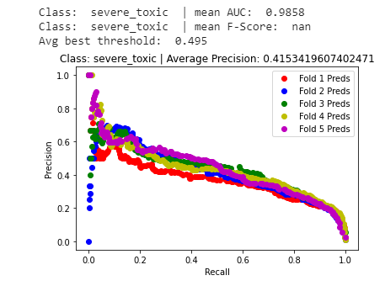

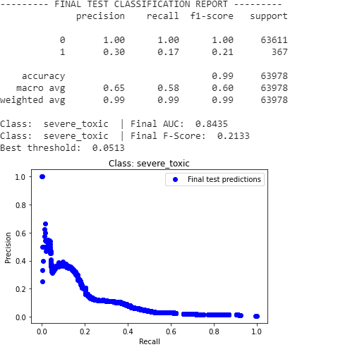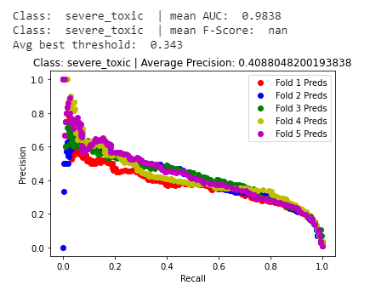

XGB w/ TFIDF + bagging/feature fraction = 0.7

and metadata features (pos + spam + added swearwords – NO LEMMATIZATION)